Course _______Specialist______ Year __12_____

Student name: ________________ Teacher name: ________________

Date: Fri week 5

Task type: Response

Time allowed for this task: _____45______ mins

Number of questions: _____6______

Materials required: No cals

Standard items: Pens (blue/black preferred), pencils (including coloured), sharpener, correction fluid/tape, eraser, ruler, highlighters

Special items: Drawing instruments, templates, , and up to three calculators approved for use in the WACE examinations
NO NOTES ALLOWED

Marks available: __39____ marks

Task weighting: _12___%

Formula sheet provided: Yes

Note: All part questions worth more than 2 marks require working to obtain full marks.

Q1 (4.1.2) (3, 3 & 3 = 9 marks)

Determine the following integrals showing full working.

Solution
Specific behaviours
uses change of variable and its derivative
derives new integral
obtains result with a constant

Solution
Specific behaviours
uses change of variable and its derivative
derives new integral
obtains result in terms of x

Solution

Alternative

Specific behaviours
uses change of variable and its derivative
derives new integral
obtains result in terms of x

Q2 (4.1.1 -4.1.3) (3, 3 & 3 = 9 marks)
Determine the following definite integrals showing full working.

Solution
Specific behaviours
uses double angle formula for cosine
obtains antiderivative
obtains exact value

Solution
Specific behaviours
uses trig identity
obtains antiderivative
subs limits to show value

Solution
Specific behaviours
uses trig identity
obtains antiderivative
subs limits to show exact value

Q3 (4 marks)
Determine the following integral showing full working.

Solution

(Note: if only two terms used- max of 2 out of 4 marks)

Specific behaviours
uses partial fractions
sets up equations to solve for constants
solves all 3 constants
anti differentiates all terms (no need to add constant)

Q4 (4.1.5-4.1.6) (5 marks)
Consider a cylindrical drill of width 2 cm that carves a cavity inside a solid sphere of radius 5 cm as shown below. Determine the volume of the sphere remaining.(Simplify)

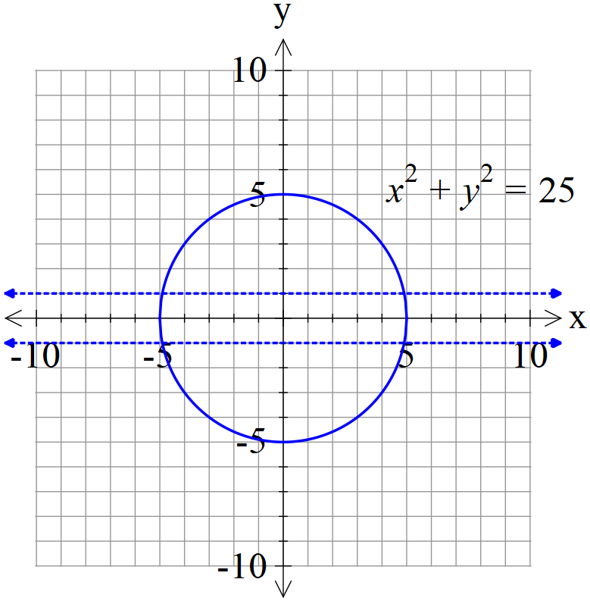

Solution

(Note- max 2 out of 5 if they have removed all of sphere between y=-1 and y=1)

Specific behaviours
solves for when y=1
uses solid of revolutions integral
sets up correct integral for volume remaining
anti-differentiates
simplifies to one term/surd

Q5 (4.2.4) (4 marks)
Determine the solution to the following differential equation given that (1,1) is a known point.(No need to simplify)

Solution
Specific behaviours
separates variables under integration
integrates y terms
integrates x terms
solves for constant (unsimplified)

Q6 (4.2.6) (1, 5 & 2 = 8 marks)
Consider the differential equation with positive constants.
- Determine the limiting value for as

Solution
Specific behaviours
states value for N

- Show how to derive using integration and partial fractions that the general solution is

Solution
Specific behaviours
separates variables
sets up partial fractions for N
shows how to find constants for partial fractions
states that a-bN>0
derives logistical formula

- Consider with an initial value of . Determine when t=50.
(No need to simplify)

Solution
Specific behaviours
solves for constant
expresses exact value at t=50

